Artificial and Computational Intelligence

ACI EC2 Questions, Sample solutions and Marking scheme
- “Imagine you are tasked with designing an automated criminal identification system for a law enforcement agency. The system is equipped with 10 surveillance cameras strategically placed in high-crime areas to monitor suspicious activities and gather evidence. It scans for individuals with matching facial features or other identifying characteristics from a database of known criminals, aiding in the apprehension of suspects and the prevention of crimes”
- Provide the complete problem formulation.
- Which agent architecture best fits? Why?
- Provide the PEAS description.
- Identify the various dimensions of the task environment with appropriate justification for each in no more than 30 words
Solution:
- Problem formulation:
Initial state: Cameras in positions, Database of suspicious activities (hand gestures, body postures, facial features), Database of high-crime areas and criminals.
Goal State: Correct identification of criminal activities and criminals.
Transition function: At(X, No criminal activity) -> At(Y, Criminal activity detected). At(X, No criminal identified) -> At(Y, Criminal identified)
Cost: Cost = Maximum detection of criminal activities and criminals and minimize false detection
- Learning agents/Utility based agent/ Goal based. Justification in not more than 30 words.
- Performance – Correct detection of criminal activities and criminals, Environment- High crime areas, people and their movement., Actuator – Scanning of peoples activities and faces, Sensors – Cameras
- Dimensions of task environment – Multi agent, continuous, deterministic, episodic, dynamic. Justification for all the dimensions
Marking scheme:
- Initial state, Goal state, Transition function, Cost – If all present 2 marks (0.5 marks each)
- Identification of agent type - 1 mark, Justification – 1 mark.
- PEAS – 2 marks (0.5 marks each)
- Dimension of the task environment (at least 4 dimensions) 1 mark, Justification 1 mark.

- Imagine you are leading a genetic algorithm optimization project for a financial forecasting system. The chromosome structure is defined as x=abcdefgh, where each gene a,b,c,d,e,f,g,h can take values between 0 and 9. The goal is to find an optimal configuration of parameters for the forecasting model. Consider the following fitness function. [ 2+4+2 = 8 Marks]
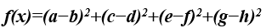
The fitness function evaluates the model's performance by measuring the squared differences between consecutive gene pairs. It encourages configurations where adjacent genes have similar values, aiming for smoother transitions in parameter space. Higher fitness values indicate configurations that result in smoother transitions between parameter values, potentially improving the overall predictive performance of the financial model.

- Describe the Chromosome representation of a parent state for four randomly selected states with their fitness score.
- Suggest an appropriate process of selection, crossover and mutation steps for this problem. Show these with only one iteration of numerical example.
- Randomization in the local search algorithm benefits the optimization problem Justify this statement with appropriate plagiarism free numerical example.

Sample Solution & Marking Scheme
- Chromosome representation of 4 randomly selected state with fitness score – 2 Marks
SAMPLE:
 | a | b | c | d | e | f | g | h
Chromosome 1 | 1 | 2 | 3 | 4 | 5 | 6 | 7 | 8
Chromosome 2 | 2 | 3 | 4 | 5 | 6 | 7 | 8 | 9
Chromosome 3 | 3 | 4 | 5 | 6 | 7 | 8 | 9 | 1
Chromosome 4 | 4 | 5 | 6 | 7 | 8 | 9 | 1 | 2

Fitness Score :
Chromosome 1 | 1 | 2 | 3 | 4 | 5 | 6 | 7 | 8

(2-1)^2 + (4-3)^2 + (5-6)^2 + (8-7)^2
= 1+ 1+1+1+1 = 4
- Selection with justification (Fitness score and Roulette wheel Mechanisms are expected)
– 1.5 Mark, without justification 0.5
Crossover steps as discussed in class- 1.5 Mark without explanation 1
Mutation with detailed explanation - 1 Mark without explanation 0.5

- Proper numerical example with justification (2 Marks)

- Consider the single player game, there are two types of food pellets available: red and blue. Pacman’s objective goal is to consume at least one red pellet and one blue pellet to end the game, (though Pacman may eat more than one of each pellet). Pacman has four directional actions up, down, left, right but cannot remain stationary.
Initial state:
 | Red |  | Blue
 | Pacman | Blue
 |  | Red

- Draw the search tree (by applying A* search algorithm) for up to exactly 3 levels (given initial state can be assumed to be on level -0).

- Find the path cost and heuristic values of all the generated nodes in the search tree. For each transition consider a uniform path cost = 5.
Path cost = transition cost + no. of remaining pellets in resultant state + no. of obstacles or black cells adjacent to Pacman’s position in the resultant state
Heuristic design for calculation:
H(n) = the smallest Manhattan distance to any remaining pellet
Note for calculation: H(n) for initial state can be calculated as below:
From Pacman’s current position, the distance to the pellet at coordinates (2,4) = 1
From Pacman’s current position, the distance to the pellet at coordinates (3,3) = 1
From Pacman’s current position, the distance to the pellet at coordinates (3,1) = 3
From Pacman’s current position, the distance to the pellet at coordinates (4,4) = 3
H(n) = min_distance(1,1,3,3) = 1

- Apply A* search algorithm for the search tree obtained from part a and using heuristic design calculated under part b, only till first 5 closed list updates or till no more nodes are left. Show the status of OPEN and CLOSED list at each level and the step-by-step procedure.

Rubrics / Marking Scheme:
- Constructing the complete tree - 3M
Search Tree if level 1 is expanded – 1 mark
Search Tree up to level 2 is expanded – 1 mark
Search Tree up to level 3 is expanded – 1 mark
- Calculation of path cost and heuristic values of all the generated nodes - 3M
Path cost calculation – 1.5 marks
Heuristic calculation – 1.5 marks
- Status of OPEN and CLOSED list at each level - 4M
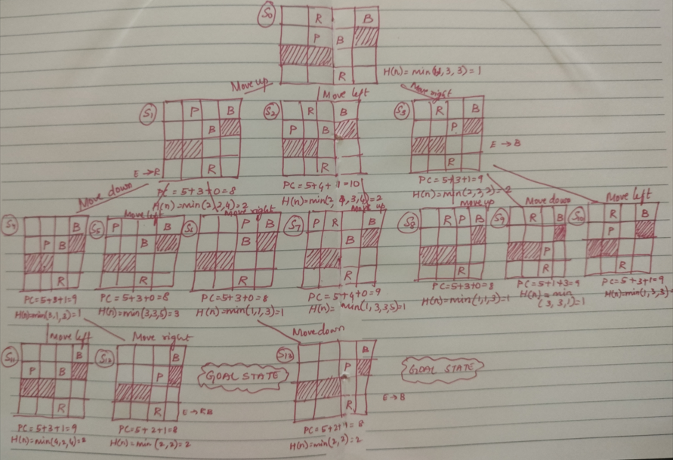

Open list | Close list | Goal | Successor
S0() | {} | Fail, S0 is not Goal state | S1(10), S2(12), S3(11)
S1(10), S2(12), S3(11) | {S0} | Fail, S1 is not Goal state | S4(10), S5(11), S6(9)
S4(10), S5(11), S6(9), S2(12), S3(11) | {S0, S1} | Fail, S6 is not Goal state | S13(10)
S13(10), S5(11), S6(9), S2(12), S3(11) | {S0, S1, S4} | S13 is Goal state
S5(11), S6(9), S2(12), S3(11) | {S0, S1, S4, S13}

- The heuristic designed for the given search problem satisfies both the admissibility and consistency properties. Evaluate the accuracy of this claim using an appropriate methodology and provide reasoning to support the conclusion.
